# Star chart:

You have 30 minutes to finish this part.

Please use only a pencil to make the drawings and markings.

After you finish the work fill your student ID on the answer sheet as well as on the sky map.

Put the answersheets in the folder; leave the compass, the ruler and the pencil on the table.

Thank you!

In this part you will use the sky-map found in the envelope. The map represents the sky in Suceava (Latitude 470 39’ North, Longitude 260 15’ East) on the day of the test at 22:00 local time. The observer who made the sky-map was at a very high altitude above Suceava; the Zenith point is in the center of the chart. Please use a pencil for marking and drawing lines on the sky-map. Use the example 1, 2 and 3 to draw lines and mark objects on the map, as seen in the figure bellow.

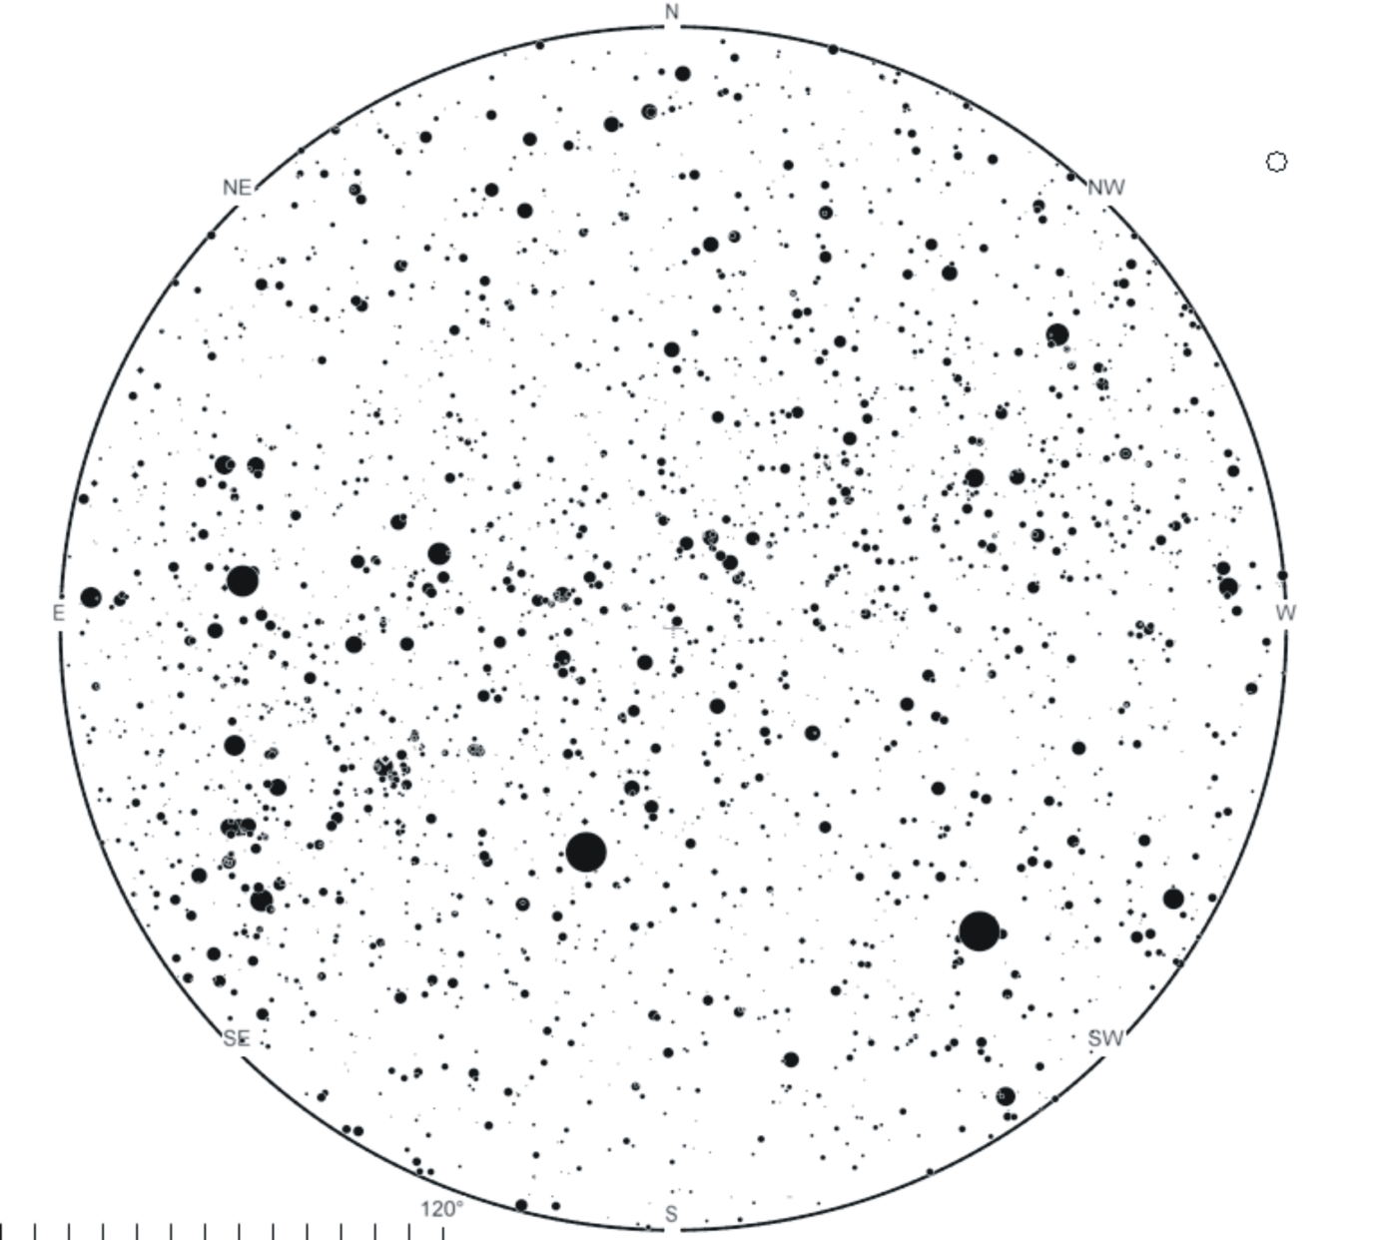

**B**

**The equatorial parallel**

**MARKING 1** This is how you will draw the curves/lines and indicate what it represents.

**5**

**MARKING 3** This is how you will mark the planets or stars. **Number of the body, star, planet etc.**

**MARKNG 2** This is how you will mark the constelations.

The letter corresponds to the name of the constellation according to table 1.

HOW TO DRAW AND MARK ON THE SKY-MAP

# Questions

The map represents the sky in Suceava (Latitude 470 39’ North, Longitude 260 15’ East) at 19:00 UT on the day of test. The observer who made the sky-map was at a very high altitude above Suceava; the Zenith point is in the center of the chart. Solve question 1 to 4 on one copy of the map and questions 5 to 8 on the second copy of map.

1. (2p) Draw on the map the horizon for an observer located on the ground in Suceava.
2. (8p) Draw the celestial equator, the ecliptic, the galactic equator and the local meridian on the map with continuous lines.
3. (9p) Mark the cardinal points (as N for north, E for east, S for south and W for west). Mark all the visible planets (except Uranus and Neptune) of the Solar System on the map and number them as 1, 2, …,6 in the order of increasing orbital radius (Skip number 3 for the Earth). Note that planets are not currently shown on the map.
4. (4p) Identify and mark the four brightest stars in visual band above the horizon line. Number the star starting from **1** – the brightest, and continue with the fainter ones till number **4** for the faintest. Fill in the following table the Bayer name of the four identified stars.

|  |  |  |  |
| --- | --- | --- | --- |
| Marking on the map | 1 | Name of the star |  |
|  |  |  |
| 2 | Name of the star |  |
|  |  |  |
| 3 | Name of the star |  |
|  |  |  |
| 4 | Name of the star |  |
|  |  |  |

1. (6p) Draw on the map, approximate figures of any 15 constellations which lie completely above the horizon. Each constellation you mark should be identified on the map with the IAU abbreviation, using **Table 1**.
2. (5p) Mark on the map the positions of the following objects:
   1. The Messier objects: M31, M27, M13;
   2.  Cygni,  Ursa Minoris.
3. (10p)

|  |  |
| --- | --- |
| Estimate the sidereal time of the map; write the value in the box. |  |

1. (6p)

|  |  |
| --- | --- |
| Estimate the equatorial coordinates (right ascension and declination) of the star Altair (α Aquilae). Write your answer in the box. |    |